Exploring Electric Vehicle Adoption and Energy Consumption Trends in the United States

line 1: 1st Given Name Surname   
line 2: *dept. name of organization   
(of Affiliation)*  
line 3: *name of organization   
(of Affiliation)*

line 1: 2nd Given Name Surname  
line 2: *dept. name of organization   
(of Affiliation)*  
line 3: *name of organization   
(of Affiliation)*

line 1: 3rd Given Name Surname  
line 2: *dept. name of organization   
(of Affiliation)*  
line 3: *name of organization   
(of Affiliation)*

*Abstract*

*This project explores electric vehicle adoption and energy usage trends across the United States, with a particular focus on data processing, analysis, and visualization. Leveraging datasets on electric vehicle registrations and historical energy values, the primary objectives were to analyze the distribution and growth of electric vehicles by type, model year, geographic location, and range, alongside tracking energy consumption trends over time. Methodologies involved extensive data cleaning and transformation, use of a MongoDB database for efficient data handling, and creation of interactive visualizations to represent findings. Key challenges included handling semi-structured data formats, integrating datasets from disparate sources, and ensuring visual clarity and interactivity in the dashboard. The final visualizations reveal significant trends, such as the concentration of electric vehicle adoption in specific counties and the historical decline in energy values. These insights offer implications for understanding the growth of sustainable energy practices and regional adoption patterns of electric vehicles in the U.S.*

*Keywords— Electric Vehicles, Energy Consumption, Data Visualization, Geographic Analysis, Sustainable Transportation*

# Introduction

The rise of electric vehicles and sustainable consumption of energy mark a critical turn in how contemporary society is dealing with its environmental challenges and resources management. The nations are looking toward reducing the carbon footprint and dependence on fossil fuels; hence, the growth of electric vehicles has become one of the promising pathways toward sustainable transportation. This project aims at analyzing the trends in the adoption of electric drive vehicles and historic energy use data across main states of the United States, based on distribution by type, model year, range, and geographic area.

Two major objectives of the project are: first, to study the factors driving the adoption and pervasiveness of electric vehicles in the U.S., and second, to look at the historical trends in values of energy use. In this paper, we employed various forms of data processing and visualization techniques in an attempt to find patterns and insight into EV adoption and how the practice is related to sustainable energy usage. Accordingly, the analysis answers the following research questions:

* What are the current distribution trends of electric vehicles in the U.S. by type, model year, and/or range, and by what states or geographic locations?
* How has energy consumption developed over time, and what social consequences can be drawn from this in view of prospective energy strategies in the U.S.?

We combined datasets sourced from multiple sources with Python for data processing and MongoDB for data storage. The project developed a series of interactive visualizations to highlight findings and make the analysis accessible. The output of the project is data-driven work for the stakeholders, which are policy makers, energy analysts, and automotive industries for better understanding of how U.S. performing to tread a path toward sustainable energy usage and at what pace electric vehicles are growing.

# Related work

The rise in the adoption of electric vehicles has spurred serious searches into influences such as technology, the environment, and government incentives. Various studies have been conducted relating to the trend of electric vehicles on issues that surround charging infrastructure, consumer preference, and policy interventions. Running parallel is comprehensive research on what the energy consumption has been in the past with its implications for current sustainability strategies. The section presents a critical overview of the related academic work by underlining their methodologies, limitations, and relevance to the current project.

EV adoption is mainly concerned with the incentives and policies provided by the government. For instance, Srivastava examined how government subsidies, tax credits, and investments in infrastructure would determine the rate of adoption of electric vehicles. The study concluded that some of the most relevant factors for electric vehicle uptake would include direct financial incentives as well as charging infrastructure [1]. However, their study is limited in that its scale is minutely geographical; their work focuses more on European countries, thus limiting applicability in the U.S. context. This project will expand such studies by analyzing EV adoption across the U.S. states, giving a more local perspective on those factors.

On consumer preferences and barriers of adoption, Pawel, conducted a comprehensive literature review. Based on this review, the main drivers for consumers considering EVs include environmental consciousness, economic perceptions, and technological acceptance [2]. While the work identified psychological factors for the adoption of EVs, it did not amply address how these trends differ among regions. Our project fills this lacuna by analyzing the geographic diffusion of EVs in the U.S., hence providing several insights into regional variations that may be predetermined by state-specific incentives or locally available infrastructure.

Another work that can be identified in regard to this involves Elena and Alberto, working on the importance of battery range as a factor in consumer adoption of EVs, showing how range constraints make a difference in the choices that are taken. For example, they prove that EVs with extended range enjoy higher rates of adoption, especially in those countries where charging infrastructure is less developed. In that direction, our analysis of the "Electric Range" distribution in the U.S. EV dataset will further develop some insights into how ranges of capabilities are going to vary and their implications for EV distribution [3].

On the contrary, regarding historic energy consumption, the work of Hannah gives a helicopter view of how transitions in energy have taken place throughout history, right from the dominance of fossil fuel energy to renewable energy sources. Indeed, Smil's work established how serious policy and infrastructural changes are needed to expedite the transition towards sustainable energy sources. However, his study was orientated mainly towards global trends and not specifically towards the U.S. It is in this breach that our project-a historical analysis of the value structure vis-à-vis energy in the U.S.-narrowly fills in the gap by offering a focused examination of the trends in energy consumption in the U.S. and thus catering to specific details on national energy policies and sustainable practices [4].

In other words, the literature review has given strength to the factors affecting EV adoption and energy consumption trends. Most studies are region-specific, or this integration of EV adoption and energy consumption in one analysis does not exist. By tacking these together, our project looks to provide an all-rounded perspective on the tussle between electric vehicle distribution and historical energy values within the U.S., offering new insights into the progress and challenges facing sustainable transportation and energy use.

# Data processing methodology

This project’s data processing methodology involved a series of steps designed to extract, clean, transform, and store the electric vehicle and energy data in a structured and accessible manner. We utilized two primary datasets for analysis: an Electric Vehicle dataset and an Energy Consumption dataset. The Electric Vehicle dataset provided a comprehensive record of electric vehicle registrations across various U.S. counties, including fields such as vehicle type, model year, range, and location. This data enabled detailed analysis of electric vehicle distribution and growth patterns. Meanwhile, the Energy Consumption dataset contained historical records on U.S. energy production, consumption, and pricing, with annual data extending over several decades. This set was used for analyzing the trends in energy consumption over time and placing the shifts in the context of sustainable energy practice. These datasets were chosen based on their relevance to the particular project objectives and how much insight they could give into the trends of sustainable transportation and energy in the U.S [5].

These were then ingested into MongoDB-a NoSQL database solution that considerably is in a better position when dealing with semi-structured data. This was quite ideal in handling the diverse formats within our datasets, including nested and variable-length data entries. Once the datasets were imported into MongoDB collections, a preliminary data cleaning phase was undertaken to prepare the data for analysis. This phase included handling missing values, standardizing field types, and removing duplicate entries. For example, essential columns like "Electric Vehicle Type" in the EV dataset and "Energy Value" in the energy dataset were scrutinized for missing values. If a missing entry was critical, it was either imputed with a default value or the record was excluded to preserve data integrity.

Data transformation was a key component of the methodology, enabling the conversion of raw data into an analysis-ready format. The energy dataset, for instance, included a “data” field with annual values stored as nested lists, which required flattening into separate columns for "Year" and "Value." This transformation facilitated a chronological analysis of energy consumption trends, aligning each year with its corresponding energy value. Additionally, aggregation techniques were applied to the EV dataset to calculate essential metrics, such as the count of vehicles by type, model year, and state. This approach allowed us to generate summary statistics, particularly for electric range, revealing patterns in vehicle capabilities over time. Filtering techniques were also used to extract region-specific insights, such as data limited to certain states, providing a more localized view of EV adoption trends.

Technologies for this project were chosen based on compatibility, efficiency, and ease of integration with our workflow. Python was the primary programming language used, supported by libraries such as Pandas for data manipulation and PyMongo for MongoDB interactions. MongoDB itself was selected due to its ability to handle semi-structured data and adapt to changing data structures without schema redesigns, which simplified data management. Finally, Jupyter Notebook provided an interactive environment that allowed us to iteratively test, refine, and document each step of the data processing pipeline, ultimately facilitating a seamless transition from data preprocessing to analysis.

The data processing workflow followed a logical sequence to ensure efficient handling of each dataset, from initial loading through to visualization. The process began with data ingestion, followed by comprehensive data cleaning and standardization to prepare the data for further transformation. Once data processing was complete, aggregated datasets were stored for quick access during the visualization phase. This structured approach enabled the efficient handling of each dataset’s unique characteristics and ensured that data was processed in an organized manner, supporting the next phase of the project.

# DATA VISUALIZATION METHODOLOGY

The data visualization phase aimed to represent key insights from the processed data in a clear, engaging, and accessible format. Visualizations were designed to provide a comprehensive view of electric vehicle distribution and energy consumption trends across the U.S. Each visualization type was selected based on the data characteristics and the specific insights it could reveal. For instance, categorical comparisons, such as the distribution of electric vehicle types, were best represented through bar charts, which allowed for easy comparison across categories. Similarly, bar charts were used to illustrate the distribution of model years within the EV dataset, capturing the growth and diversity of EV models over time. These choices were informed by visualization theory, which suggests that bar charts are effective for categorical data as they emphasize magnitude differences across categories.

The energy consumption data, being temporal, required a format that could effectively show trends over time. A line chart was chosen to depict changes in energy consumption year by year, providing a clear view of the data’s chronological progression. This format allowed viewers to observe fluctuations in energy values over decades, highlighting periods of significant increase or decrease and offering insights into long-term energy trends. Geographic data, meanwhile, was represented through a choropleth map, which illustrated the distribution of electric vehicles by state. This visualization format effectively highlighted regional variations in EV adoption, showing the concentrations of electric vehicle registrations in specific areas. By using shades of color to indicate density, the map conveyed information on geographic adoption trends in a way that is easy to interpret.

To enhance readability and engagement, a consistent color scheme was applied across all visualizations, with shades of blue and neutral tones providing a clean and professional appearance. Blues were used to represent different data intensities, particularly in maps, with darker hues indicating higher values. This approach was chosen based on color theory principles, ensuring that the colors were accessible and did not cause visual fatigue. Interactive elements, such as hover tooltips, were incorporated into each visualization using Plotly within Jupyter Notebook. These tooltips displayed additional data when users hovered over elements, providing contextual information without cluttering the visual space. Additionally, the dashboard included interactive filtering options, allowing users to explore specific aspects of the data, such as filtering EV types by state or viewing energy values by selected years.

The dashboard was structured to ensure logical flow and ease of navigation. It begins with overviews of electric vehicle types and model years, allowing users to understand the types of EVs and their growth trajectory. This is followed by geographic data, offering a spatial view of EV distribution across states. The final visualization presents energy data trends, situating EV adoption within the broader context of energy consumption over time. Each visualization was paired with a title and a brief description to guide viewers through the data, ensuring that each chart could be understood independently. This approach was intended to create a cohesive and accessible user experience, providing a comprehensive perspective on EV adoption and energy usage trends in the U.S.

Challenges encountered during this phase included managing geographic data consistency, particularly when attempting to match county data without FIPS codes. To address this, we limited our geographic focus to state-level data for broader consistency. Additionally, balancing detail with readability required careful consideration, as too much data detail could overwhelm viewers. The use of interactive tooltips and filters helped mitigate this, offering additional information on demand without cluttering the visuals. In summary, the data visualization methodology combined best practices in visualization theory with careful design choices, resulting in an informative and engaging dashboard that effectively presents the data’s key insights.

# RESULTS AND EVALUATION

The analysis below depicts key trends in the distribution of electric vehicles with historic energy consumption across the U.S., which may be of great help in understanding the growth of the trend in sustainable practices.

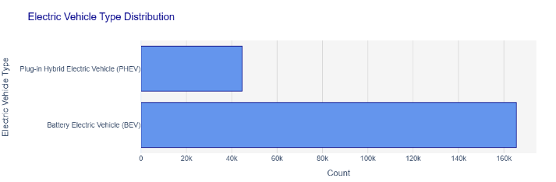The bottom line then is that electric vehicle-type distribution is a pretty transparent preference on the part of consumers for BEVs over PHEVs, whereby roughly 80% of every registration of EVs constitutes BEVs. Given this trend, it seems that consumers increasingly favor fully electric models, maybe due to improved charging infrastructure and a greater awareness of the environment.

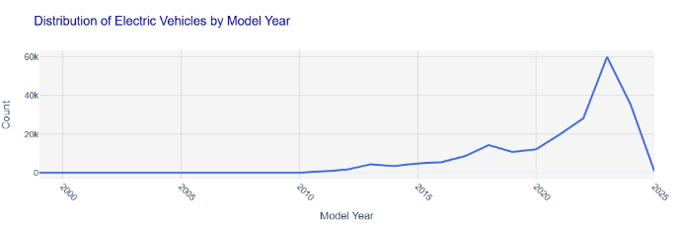

At the distribution of model years, there was an astonishing growth in EV registrations from 2019 onwards, not only overall but with significant spikes, especially for the 2020 model year. The indications are that this is due to recent technological advancements and the increasing public interest in EVs. That rapid growth in adoption is accelerating the shift of consumer demand and policy incentives toward clean transportation.

This graph ranges from less than 100 to over 300 miles on a single charge. And, more to the point, many of the newest bodies break nicely through the 200-mile threshold where range anxiety really starts to dissipate. Put simply, this graph shows that improvements in battery technology are chipping away at the "range anxiety" barrier, making EVs more and more practical for a wider range of users.

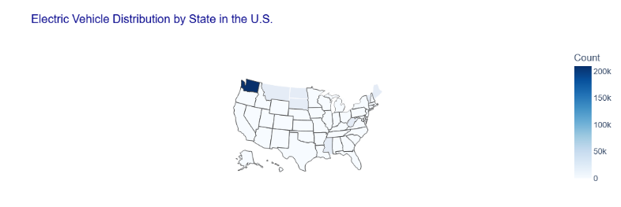

The choropleth map reflects a highly varied geographic distribution of EVs in states like Washington. This reflects state-specific incentives and infrastructure that are supportive of the uptake and local policy that plays a large role in variation in regional uptake.

Finally, Energy Consumption Trends show a gradual decline in energy values over the recent years, which might indicate a shift towards energy efficiency and probably increase in cleaner sources of energy. Such a decrease in energy values would be consistent with growing EV adoption and therefore at least would suggest a positive feedback loop: the cleaner the energy, the lower the environmental impact of an EV.

In general, this analysis provides actionable insights into making transport and energy policy sustainable for all its stakeholders. Furthermore, supportive infrastructure and vehicle range improvement, together with regional policy, are underlined as the key elements to diffusion. Data also support a wider trend of sustainability, as reduced energy use is complementary to switching to electric vehicles.

This interactive dashboard was developed in the project, where dynamic data exploration enables a range of stakeholders to engage with these findings and draw out insights to inform policy and investment decisions in both the EV and energy sectors.

# CONCLUSION AND FUTURE WORK

This exercise provided an overview of the domestic trend of electric vehicle adoption and distribution in light of historic trends in energy use within the U.S. How the results of the data analysis look in the form of interactive visualization, where technologies-advance-driven preference shift towards Battery Electric Vehicles from conventional hybrid ones has been favored by changing consumer priorities. This analysis also provides clear evidence of the upward trend in recent-year EV registrations as policy support strengthens, and there grows an awareness of sustainability benefits. Plus, regional variations in EV adoption put further emphasis on the role of state-level infrastructure and incentives in preserving high-adoption areas like Washington state.

There has been a gradual decline in the historical trend of energy consumption, which might indicate that there's indeed a shift toward energy efficiency and cleaner sources to complement the rise of the EVs. Using the provided interactive dashboard, stakeholders can explore these findings in detail and see a complete picture of shifting sustainable transportation trends in the U.S.

This present study has a number of limitations. Because of data availability, the geographic data on EV distribution were constrained to state-level insights. Future research might focus on finer geographic detail-such as county-level data-to better capture localized adoption patterns. Moreover, extending this analysis into real-time or updated datasets would yield timely insight into emerging trends. Adding data on related factors, such as charging infrastructure or regional emissions, would even further enhance it.

In other words, the results of this study give an overview of main supportive policies, infrastructure, and technological advances that drive EV adoption. The positioning of EVs in relation to the low-emission economy and support for a cleaner future is also well elaborated. Further research based on these findings could be used to guide policy decisions, infrastructure investments, and public awareness that are supportive of sustainable growth in both the EV and energy sectors.

##### References

[1 A. Srivastava, R. R. Kumar, A. Chakraborty, A. Mateen, and G. Narayanamurthy, “Design and selection of government policies for electric vehicles adoption: A global perspective,” *Transportation Research Part E: Logistics and Transportation Review*, vol. 161, p. 102726, May 2022, doi: <https://doi.org/10.1016/j.tre.2022.102726>.

[2] P. Bryła, S. Chatterjee, and B. Ciabiada-Bryła, “Consumer Adoption of Electric Vehicles: A Systematic Literature Review,” *Energies*, vol. 16, no. 1, p. 205, Dec. 2022, doi: <https://doi.org/10.3390/en16010205>.

[3] E. Higueras-Castillo, A. Guillén, L.-J. Herrera, and F. Liébana-Cabanillas, “Adoption of electric vehicles: Which factors are really important?,” *International Journal of Sustainable Transportation*, vol. 15, no. 10, pp. 1–15, Sep. 2020, doi: <https://doi.org/10.1080/15568318.2020.1818330>.

[4] H. Ritchie and P. Rosado, “Fossil Fuels,” *Our World in Data*, Oct. 02, 2022. <https://ourworldindata.org/fossil-fuels>

[5] Data.Gov, “Data.gov,” *Data.gov*, Sep. 14, 2020. https://data.gov/